Classification and Stress Analysis Using Artificial Neural Network

Parth Matalia
Student, K J Somaiya College of Engineering, Somaiya Vidyavihar University
Email: p.matalia@somaiya.edu

Amod Zack
Student, K J Somaiya College of Engineering, Somaiya Vidyavihar University
Email: amod.zack@somaiya.edu

Dinesh Chawde
Assistant Professor, Department of Mechanical Engineering, K J Somaiya College of Engineering, Somaiya Vidyavihar University
Email: dineshc@somaiya.edu
Abstract
Pressure vessels, vital in the Energy Sector, are required to go through rigorous structural safety assessments. Traditional stress analysis methods are effective but integrating artificial intelligence (AI), particularly deep learning with neural networks like Convolutional Neural Networks (CNN), enhances precision. This work explores Artificial Intelligence & Machine Learning (AI & ML) application in revolutionizing pressure vessel’s stress analysis, encompassing dataset examination, AI model development, robust evaluation metrics, and real-world user interactions. Results indicate the successful model functioning, paving the way for further exploration in this transformative concept.

Keywords: Pressure Vessels, Stress Analysis, Neural Networks.
1. Introduction
The energy sector heavily relies on pressure vessels for various purposes, such as containing harmful gasses in oil refineries and metal-works. Nuclear power plants utilize specialized pressure vessels called Reactor Pressure Vessels (RPVs), which are crucial in withstanding high temperatures, pressures, and neutron irradiation. To avoid the failure of these pressure vessels, it is crucial to perform stress analysis accurately. Finite Element Analysis (FEA), a software-based method widely adopted in engineering, utilizes calculations, models, and simulations to predict an object's behavior under varying conditions. The finite element method (FEM) is employed, breaking down the structure into elements connected at nodes. This numerical technique generates algebraic equations for engineers to analyze stress, thermal behavior, seismic calculations, etc. [10]. Leading companies like Autodesk, Ansys, and Dassault Systems provide FEA software for comprehensive engineering solutions. Artificial Neural Network (ANN), a Deep Learning (DL) method inspired by the human nervous system, employs interconnected nodes to transfer data between layers as depicted in Fig. 1 [9]. Widely used in deep learning for image classification, speech/character/image recognition, natural language processing, and computer vision, ANN functions as a sophisticated data processing system. The fusion of FEA and ANN represents a novel research avenue, exploring the potential of combining established engineering analysis with advanced artificial intelligence. This paper delves into this uncharted territory, presenting the initial steps towards a groundbreaking concept. The discussion explores insights and findings, laying the groundwork for a potential paradigm shift in engineering practices.
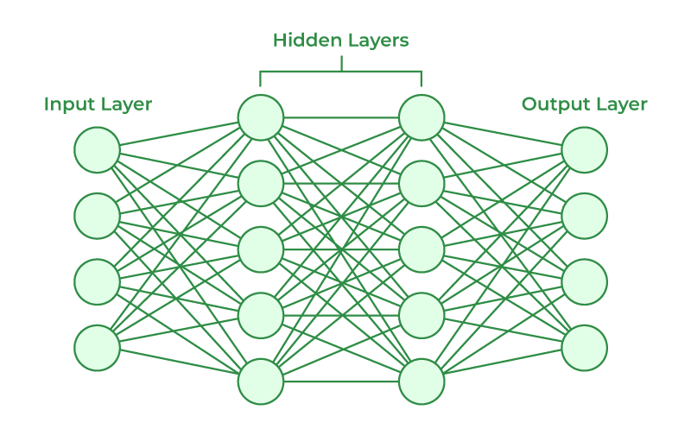

Fig. 1 A Generic Artificial Neural Network [9]

2. Literature Review
This section emphasizes literature surveys done in the three major areas - Machine Learning & Pressure Vessel Safety Assessment, Neural Networks in Structural Damage Recognition, Custom Imageset Creation Techniques.

2.1. Machine Learning & Pressure Vessel Safety Assessment
There have been many recent contributions to the field of pressure vessel safety and structural integrity assessment through ML techniques. DL is the foremost refinement of ML and various Neural Networks are being trained as of this moment. The focus is on various studies that leverage ML techniques for safety assessment, risk evaluation, stress prediction, burst pressure estimation, damage recognition in pressure vessels, pipelines and how to employ Neural Nets for the same. Shah et al. [1] explore the application of machine learning for design-by-analysis of pressure equipment, showcasing how ML can supplement or replace manual procedures in finite element analysis (FEA). Another perspective on risk assessment for pipelines with active defects is provided by Anghel [2], emphasizing the use of artificial intelligence methods to evaluate risks in in-service pressure piping containing defects. From the Analytical Perspective, Chawde and Bhandakkar [11], addressed semi analytical method to solve mixed boundary value problems, contributing to the understanding of structural behavior of functionally graded pressure vessel. Khadke and Chawde [12], designed a thin cylindrical pressure vessel subjected to multiple loading and performed finite element analysis using ANSYS. Therefore, Artificial Intelligence is pivotal in manufacturing and detecting errors in the Pressure Vessel industry.

2.2 Neural Networks in Structural Damage Recognition
A safety assessment approach to pressure vessels based on machine learning by Zhang et al. [3] investigates the elastoplastic 3D J-integral of a crack tip, providing insights into safety assessment methodologies using ANN. Zolfaghari and Izadi [4] propose a burst pressure prediction model for cylindrical vessels using artificial neural networks (ANNs), incorporating input parameters such as internal and outer diameter, thickness, ultimate and yield strength. Johnson et al. [5] demonstrate the use of ANN for predicting burst pressure of both thick and thin-walled pressure vessels, addressing various strain hardening carbon steels. Fan and Hu [6] present a paper on pressure vessel nozzle local stress prediction software, incorporating ABAQUS and ML techniques to obtain accurate stress values. Modarres et al. [7] introduce a CNN-based approach for automated damage recognition and identification of structural damage types in pressure vessels. The above section illustrates that Deep Learning can be used to further improve the efficiency of ML Techniques used in Stress Analysis and Detection of Pressure Vessels.

2.3 Custom Imageset Creation Techniques
Utilizing learnable convolutional filters, Bajpai and He [8] detail a methodology for creating custom datasets and utilizing CNN models for image processing operations in Google's T-Rex game, showcasing the versatility of ML in various applications. Thus, the creation of custom datasets and application of CNN models in image processing is easier with Machine Learning techniques.
3. Problem Definition, Methodology & Model Used
3.1 Problem Definition
This study proposes a method that combines ANN and stress analysis to provide an accurate and efficient model for classification of pressure vessels and prediction of stresses. Eventually, this model aims to provide an approach to enhance safety management and operational efficiencies in the industrial sector. For the imageset, illustrations are created using images of pressure vessels that can be found online. The images are stored in Google Drive and are used for the process that is followed in this model.
3.2 Methodology
Our innovative approach involves the integration of ANN and Stress Analysis for classifying pressure vessels and predicting stress. A diverse dataset, encompassing various pressure vessel types, material parameters, and results, underwent meticulous preprocessing for ANN training. Multiple ANN structures were explored, optimizing through regression methods and hyperparameter tuning to achieve the desired performance. Trained models underwent rigorous testing for accuracy and precision.

3.3 Model Used
The architecture is divided into three flow structures, with the primary focus on classifying pressure vessels. A homogeneous image dataset was crucial for this, leading to the first structure.
- Imageset Creation
- Classification Of Pressure Vessels
- Stress Prediction
3.3.1 Imageset Creation
The following Fig. 2 depicted the steps in imageset creation as:
- Data Preprocessing
Google Drive integration in Colab facilitated dataset access. Libraries like os, PIL.Image, and Sklearn were imported for preprocessing.
- Image Processing
Images underwent processing, including format conversion, resizing, and detail filtering. Dataset organization into training and testing sets followed.
- Dataset Creation
Directories were defined, existing ones removed, and new ones created. The dataset was split into training and testing sets using train_test_split. This laid the foundation for neural network training.
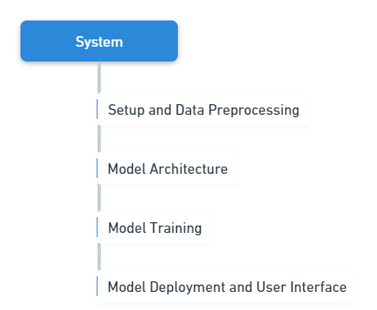
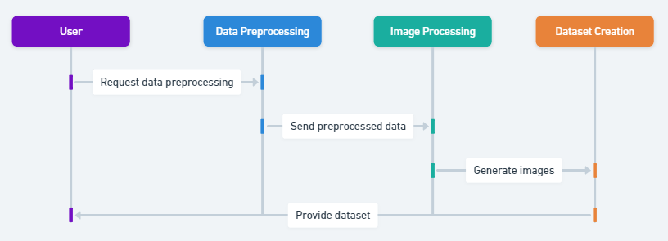
Fig.2 The flow and interconnectivity of the process to obtain the training and testing Imageset
Fig.3 The linear flow of the intermediate process to classify the obtained Imageset
3.3.2 Classification of Pressure Vessels
The steps involved in classifying the pressure vessel consist of following steps and are depicted in Fig. 3.
- Setup and Data Preprocessing
Google Drive was mounted, TensorFlow and relevant modules imported. Image data generators with augmentation techniques were configured.
- Model Architecture
A Convolutional Neural Network (CNN) with three convolutional layers, max-pooling, and dense layers was designed for binary classification as shown in Fig. 4. The model was compiled with Adam optimizer and categorical cross-entropy loss.
- Model Training
The model was fitted to the augmented training dataset using Model Checkpoint and Early Stopping callbacks. Training involved 20 epochs.
- Model Deployment and User Interface
Saved models were loaded, providing a user interface for predictions. Users could correct predictions through feedback buttons
- User Feedback Loop
User feedback influenced model re-evaluation. Corrected labels were added to images, and the updated model was saved.
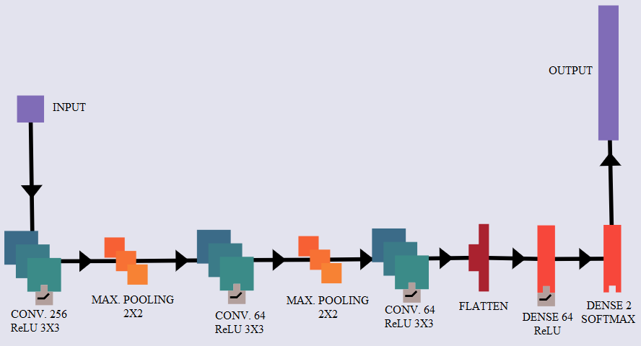

Fig.4 Architecture of the Convolution Model

3.3.3 Stress Prediction
This stress prediction model, as shown in Fig. 5, uses a feedforward neural network for stress prediction, incorporating input, hidden, and output layers. K-fold cross-validation ensured robust evaluation. The model, compiled with Adam optimizer, utilized mean squared error as the loss function and mean absolute error as a metric. A test dataset containing the parameters temperature (T), thickness (t), radius (R), inner radius (r), ellipticity (a), and pressure (P) of the vessel as well as the recorded stress values at such conditions are used in this model.
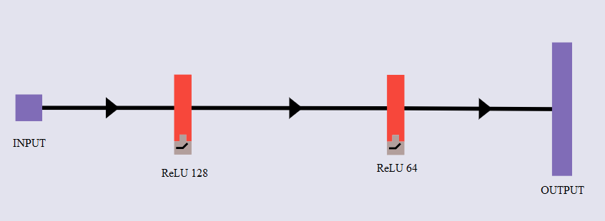

Fig.5 Stress Prediction Model

4. Results & Discussion
Vertical pressure vessels are large structures widely used in the oil and gas industry to store oil and other liquids. They have several different trays designed to mix rising air and falling water. The container looks like a horizontal drum with two mold heads, one at the top and one at the bottom. It is supported by a coat welded to the lower head. The following two test cases were considered to test the classification model designed by us.
TEST CASE 1: The classification model was provided with a pre-processed image of a used 225-gallons (GAL) Ventech Carbon Steel Tank; Rated 232 psig @ 752 F; Dished top and bottom; Leg mounted Vertical Pressure Vessel with an estimated weight of 2,000 lbs; Built in 2015 [13]. The model predicted incorrectly as shown in Fig.6, thus the feedback loop was established, and the model learned the correct category of the image as shown in Fig.7.
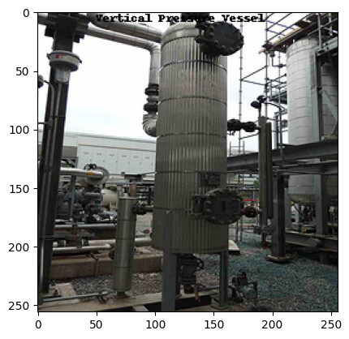
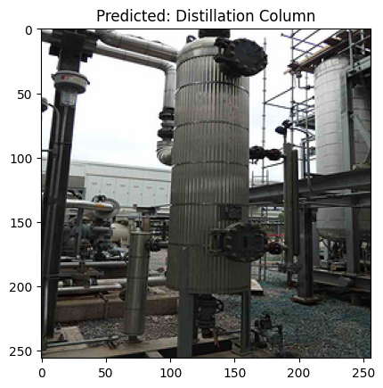

Fig.7 Predicted Vertical Pressure Vessel
Fig.6 Vertical Pressure Vessel
TEST CASE 2: The classification model was provided with another Vertical Pressure, LOB’s WTP heated vessel with conical outlet and heated support brackets vessel as shown in Fig.8. LOB’s WTP-heating system serves as an alternative to the half-tube coil and double-walled jacket [14]. The model predicted correctly; thus, the stress calculation model was called upon. This model, which was provided with the parameters and dataset predicted the stress with an error of 0.265 MPa as shown in Fig 9.
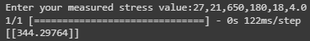
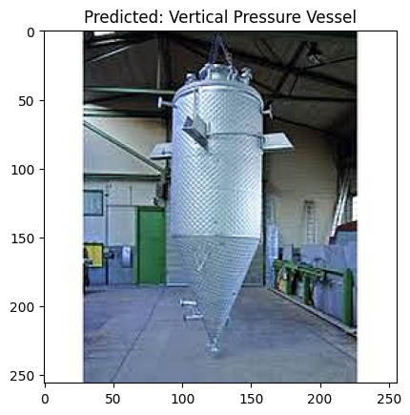

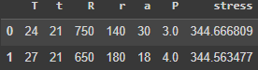

Fig.9 User –Input of Parameter and obtained result
Fig.8 Predicted Vertical Pressure Vessel

5. Conclusion
The completed study demonstrates a reliable and efficient Convolutional Neural Network method for classifying images and analyzing stresses of pressure vessels. Constructed using TensorFlow's Keras API, the CNN architecture exhibits a deliberate design intended to extract complex patterns from input images to produce precise predictions. Three convolutional layers make up the model. To minimize categorical cross-entropy loss during the training phase, the Adam optimizer is employed. A feedforward neural network for stress prediction is incorporated by the model. Also, a test data set containing various vessel parameters such as temperature, pressure, thickness, etc. is used for stress prediction. Furthermore, the study has a comprehensive user interface for real-time prediction and feedback. With the help of this interactive feature, end users can offer constructive insights, which helps the model go through an iterative improvement cycle. With this study as a foundation, designing, monitoring, as well as maintenance of Pressure Vessels can be made highly efficient. The real-time monitoring of various parameters of a working pressure vessel is highly useful, especially in the Energy Sector where the margin of error is extremely low.

References

- Shah, Chandnani, Raykar, Mavinkurve, “Application of Machine Learning for Design-by-Analysis of Pressure Equipment” (2019),
DOI:10.1109/ICNTE44896.2019.8945858
- Anghel, “Risk assessment for pipelines with active defects based on artificial intelligence methods” (2009), DOI: 10.1016/j.ijpvp.2009.01.009
- Zhang, Hu, Shi, Liang, Xu, Cao, “A safety assessment approach to pressure vessels based on machine learning” (2022), DOI:10.3389/fmats.2022.1051890
- Zolfaghari, Izadi, “Burst Pressure Prediction of Cylindrical Vessels Using Artificial Neural Network”(2020), DOI:10.1115/1.4045729
- Johnson, Zhu, Sindelar, Wiersma, “Artificial Neural Networks for Predicting Burst Strength of Thick and Thin-Walled Pressure Vessels”(2023), DOI:10.1115/PVP2023-106471
- Fan, Hu, “Pressure vessel nozzle local stress prediction software based on ABAQUS- machine learning” (2023), DOI: 10.1016/j.softx.2023.101550
- Modarres, Astorga, Lopez-Droguett, Meruane, “Convolutional neural networks for automated damage recognition and damage type identification”(2018), DOI:10.1002/stc.2230
- Bajpai, He, “Custom Dataset Creation with Tensorflow Framework and Image Processing for Google T-Rex” (2020), DOI: 10.1109/CICN49253.2020.9242565
- R.M. Baphana, S. Gupta and S. Alegavi, “Fundamentals of Neural Networks.” Deep Learning (2023)
- Seshu, P., “Finite-element analysis”, ISBN:9788120323155, 8120323157, Publisher: PHI Learning, (2004)
- Chawde, Dinesh P., and Tanmay K. Bhandakkar, "Mixed boundary value problems in power-law functionally graded circular annulus." International Journal of Pressure Vessels and Piping 192 (2021), DOI: 10.1016/j.ijpvp.2021.104402
- Kunal. Khadke and Dinesh Chawde.: Design & Finite Element Analysis of Pressure Vessels. International Journal for Research in Applied Science & Engineering Technology, vol. 10, no. 7, pp. 4741–4748 (2022). DOI: 10.22214/ijraset.2022.46076
- Test Case 1: “225 GAL Ventech Carbon Steel Tank”, S/N 8000-032-V591, NB # 64
- Test Case 2: “LOB’s WTP heated vessel with conical outlet and heated support brackets”, SG100332-Kopie-2.jpg

